**GCAT – Gateway Configuration Automation Tool (Java)**

* ***Version 1.01***

1. ***Initial Setup***

After installing the application go to Edit -> Settings and update the input/output and git path.

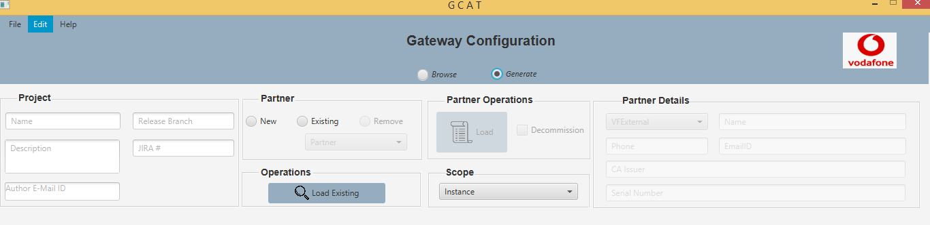

Fig 1

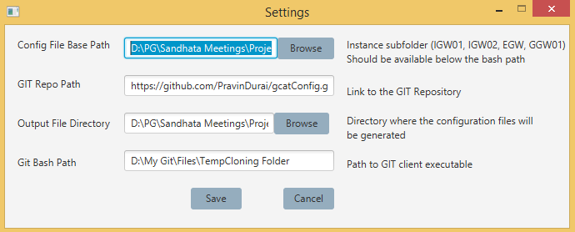

Fig 2

Close and re-open the application for the changes to take place.

1. ***Generate Mode***

Once you switch to generate mode we should be able to see certain features that were getting enabled. This allows you to create new/update the existing cfg files specified in the path (Fig 2).

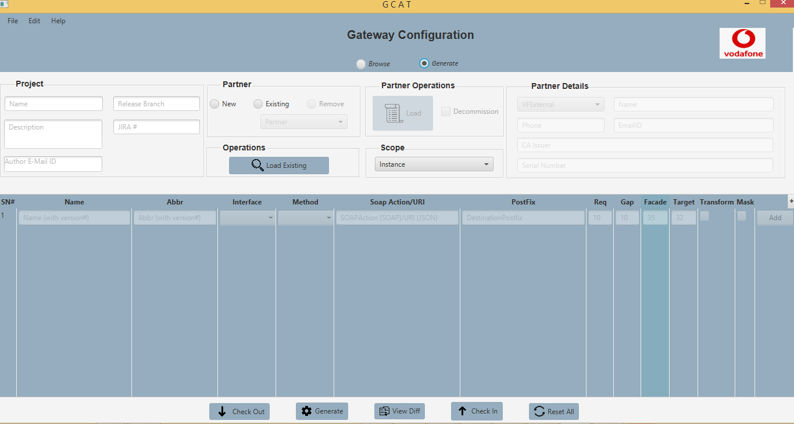

Fig 3

1. ***Creating New Partner***

Create a new partner by switching to “New” under Partner.

Once we select New as option we should be able to see Partner Details getting enabled.

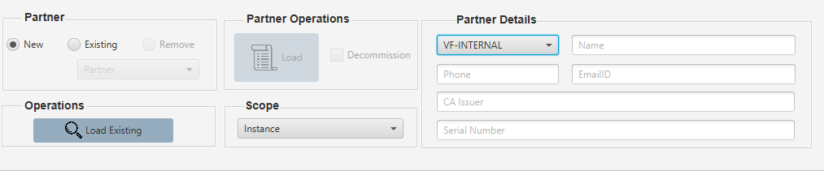

Fig 4

1. ***Existing Partner***

For existing partner

1. Select the mode as “Generate”
2. Select Instance under Scope.
3. Select “Existing” under Partner.
4. Select the partner from the list of available partners from partner drop-down under Partner.
5. Click “Load” under Partner Operation

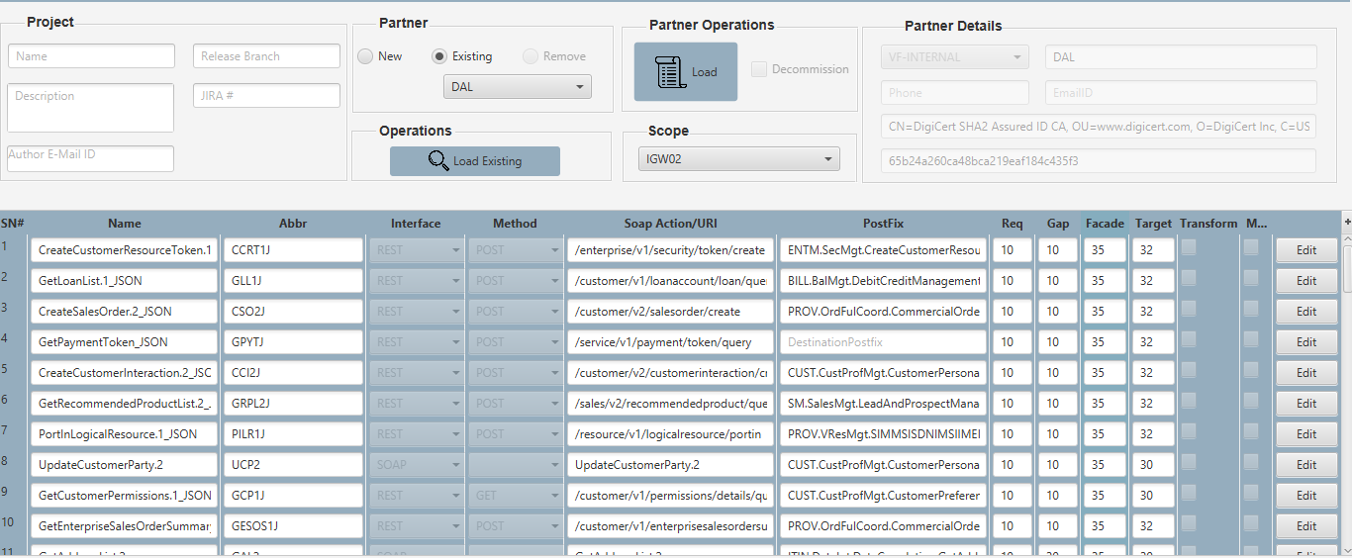

Fig 5

***Note*** :

Make sure partner details are getting populated under “Partner Details” when you click load. When you click on load all the existing operation for the selected partner will be loaded into the grid.

1. ***Create New Operation***

For creating a new operation,

1. Select mode as “Generate”
2. Select an Instance under scope for which you wish to add a new operation
3. Enter the details of the operation in the grid and click “Add” (Fig 6)
4. New entries (Fig 7)

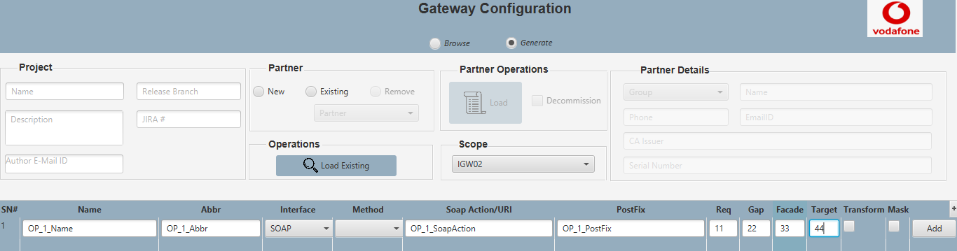

Fig 6

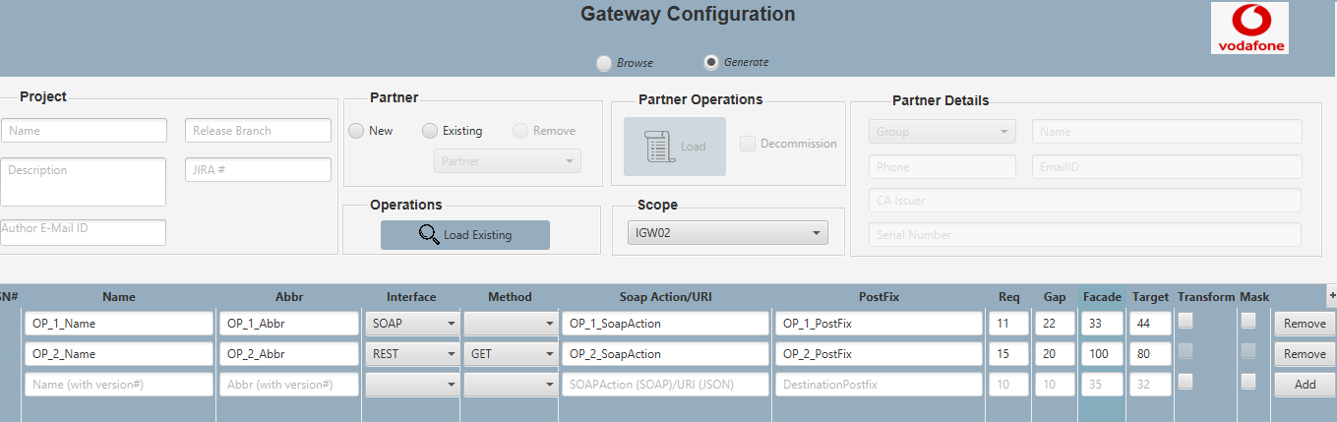

Fig 7

1. ***Loading Existing Operation***

To load an existing operation,

1. Select mode as “Generate”
2. Select an instance under scope
3. Click “Load Existing” under Operations (Fig 8). Now Operation popup opens displaying the list of available operations for the selected instance (Fig 9)

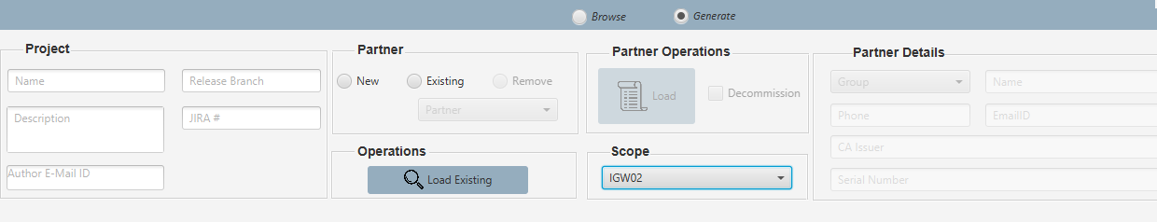

Fig 8

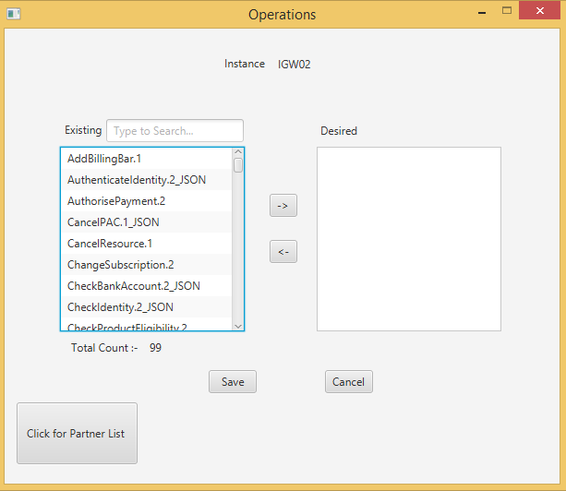

Fig 9

1. Select the operation/operations (use Shift/Ctrl keys) that has to be added for the new/existing partner (Fig 10)

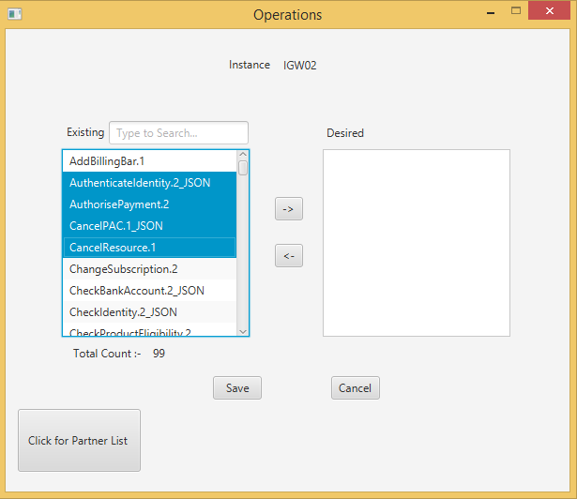

Fig 10

1. Once selected we can use the move buttons to move the operation to the right (Fig 11)
2. Click Save. The selected operation on the right will be exported to the grid along with their data

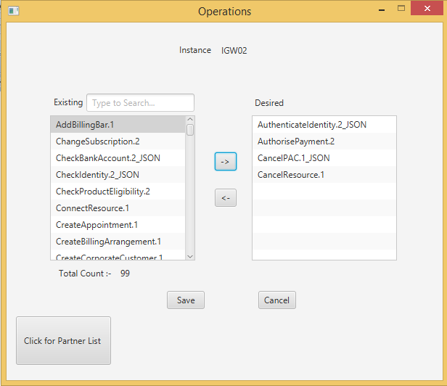

Fig 11

1. ***Generating new cfg file***

To generate new configuration/to update existing configuration

1. Select mode as “Generate”
2. Select an instance under Scope
3. Select New/Existing partner under “Partners”

* New partner – Section III
* Existing Partner – Section IV

1. Enter New/Select Existing Operation

* New Operation – Section V
* Existing Operation – Section VI

1. Click Generate
2. The files will be created in the output path specified in (Fig 2).
3. ***Editing Existing Operation***

To edit an existing operation

1. Select mod as “Generate”
2. Select an instance under Scope
3. Click Existing Operation (Section IV)

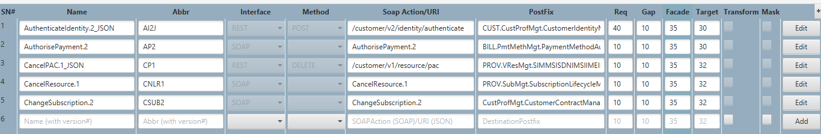

1. Once the existing operations are loaded, select “Edit” button in the grid and you should be able to make the required changes and once the changes are made click save for the changes to reflect.

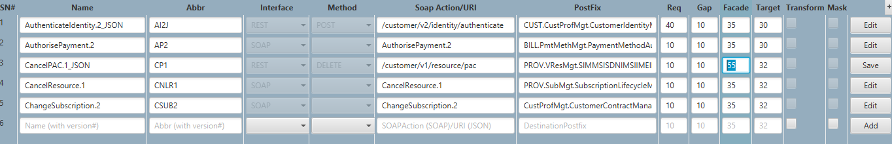

***Note :***

With the existing version of the tool we can edit only Req, Gap, Facade, Target.

We can also enable or disable transform and mask for SOAP request but not for REST.

1. ***View Difference***

This feature allows us to check the files that are modified. To compare the difference,

1. Select the instance under scope
2. Click ViewDiff button.